

**Experiment 8**

**Date of Performance:** 17 April 2023 **Date of Submission:** 17 April 2023

**SAP Id:** 60004200132 **Name :** Ayush Jain

**Div:** B **Batch :** B3

**Aim of Experiment**

Implement Diffie Hellman Key exchange protocol. Demonstrate man in middle attack.

**Theory / Algorithm / Conceptual Description:**

Diffie-Hellman algorithm

The Diffie-Hellman algorithm is being used to establish a shared secret that can be used for secret communications while exchanging data over a public network using the elliptic curve to generate points and get the secret key using the parameters.

For the sake of simplicity and practical implementation of the algorithm, we will consider only 4 variables, one prime P and G (a primitive root of P) and two private values a and b.

P and G are both publicly available numbers. Users (say Alice and Bob) pick private values a and b and they generate a key and exchange it publicly. The opposite person receives the key and that generates a secret key, after which they have the same secret key to encrypt.

Steps:

|  |  |
| --- | --- |
| Alice | Bob |
| Public Keys available = P, G | Public Keys available = P, G |
| Private Key Selected = a | Private Key Selected = b |
| Key generated =  x = G^a mod P | Key generated =  y = G^b mod P |
| Exchange of generated keys takes place | Exchange of generated keys takes place |
| Key received = y | Key received = y |
| Generated Secret Key =  k_a = y^a mod P | Generated Secret Key =  k_b = x^b mod P |

Algebraically, it can be shown that k_a = k_b

Example:

Step 1: Alice and Bob get public numbers P = 23, G = 9

Step 2: Alice selected a private key a = 4 and Bob selected a private key b = 3

Step 3: Alice and Bob compute public values Alice: x =(9^4 mod 23) = (6561 mod 23) = 6 Bob: y = (9^3 mod 23) = (729 mod 23) = 16

Step 4: Alice and Bob exchange public numbers

Step 5: Alice receives public key y =16 and Bob receives public key x = 6

Step 6: Alice and Bob compute symmetric keys Alice: ka = y^a mod p = 65536 mod 23 = 9 Bob: kb = x^b mod p = 216 mod 23 = 9 Step 7: 9 is the shared secret.

**Program**

|  |
| --- |
| from random import randint  from math import sqrt  def isPrime(n):  if (n <= 1):  return False  if (n <= 3):  return True  if (n % 2 == 0 or n % 3 == 0):  return False  i = 5  while(i * i <= n):  if (n % i == 0 or n % (i + 2) == 0) :  return False  i = i + 6  return True  def findPrimefactors(s, n):  while (n % 2 == 0):  s.add(2)  n = n // 2  for i in range(3, int(sqrt(n)), 2):  while (n % i == 0):  s.add(i)  n = n // i  if (n > 2):  s.add(n)  def getPrimitiveRoot(P):  s = set()  if (isPrime(P) == False):  return -1  phi = P - 1  findPrimefactors(s, phi)  for r in range(2, phi + 1):  flag = False  for it in s:  if (pow(r, phi // it, P) == 1):  flag = True  break  if (flag == False):  return r  return -1  P = int(input("Enter value of P: "))  G = getPrimitiveRoot(P)  print('The Value of G is: %d'%(G))  a = randint(2, P-1)  b = randint(2, P-1)  print('The Private Key a for A is: %d'%(a))  print('The Private Key b for B is: %d'%(b))  xa = int(pow(G,a,P))%P  xb = int(pow(G,b,P))%P  ka = int(pow(xb,a,P))%P  kb = int(pow(xa,b,P))%P  print('Secret key for the A is: %d'%(ka))  print('Secret Key for the B is: %d'%(kb)) |

|  |
| --- |
| **Output** |

**Man in the middle attack:**

In a man-in-the-middle attack, an attacker intercepts the communication between two parties and impersonates each party to the other. In the context of the Diffie-Hellman key exchange, the attacker would intercept the public keys sent by each party, replace them with their own public key, and then forward them to the intended recipient. The attacker would then compute their own shared secret key with each party, which would be different from the shared secret key that the two parties would compute with each other.

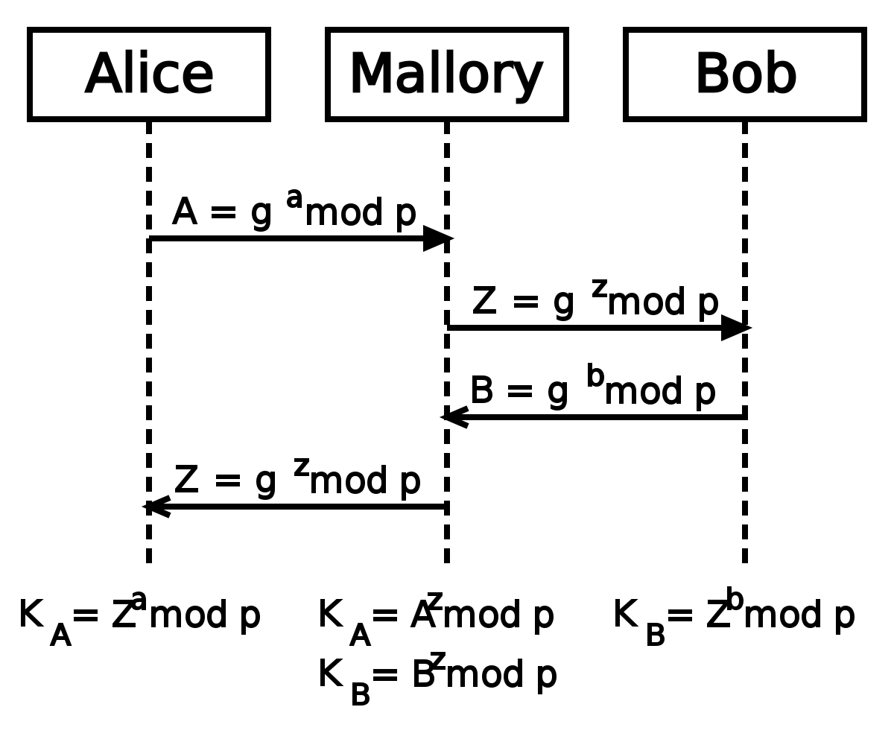

**Step by Step explanation of this process:**

Step 1: Selected public numbers p and g, p is a prime number, called the “modulus” and g is called the base.

Step 2: Selecting private numbers.

let Alice pick a private random number a and let Bob pick a private random number b, Malory picks 2 random numbers c and d.

Step 3: Intercepting public values,

Malory intercepts Alice’s public value (ga(mod p)), block it from reaching Bob, and instead sends Bob her own public value (gc(modp)) and Malory intercepts Bob’s public value (gb(mod p)), block it from reaching Alice, and instead sends Alice her own public value (gd (modp))

Step 4: Computing secret key

Alice will compute a key S1=gda(mod p), and Bob will compute a different key, S2=gcb(mod p)

Step 5: If Alice uses S1 as a key to encrypt a later message to Bob, Malory can decrypt it, re-encrypt it using S2, and send it to Bob. Bob and Alice won’t notice any problem and may assume their communication is encrypted, but in reality, Malory can decrypt, read, modify, and then re-encrypt all their conversations.

To **prevent** man-in-the-middle attacks in the Diffie-Hellman key exchange, the two parties should authenticate each other's public keys using digital signatures or a trusted third party. Additionally, the communication channel should be encrypted using a secure encryption algorithm, such as AES, to prevent eavesdropping by the attacker.

**Code:**

|  |
| --- |
| import random  # public keys are taken  # p is a prime number  # g is a primitive root of p  p = int(input('Enter a prime number: '))  g = int(input('Enter a primitive root of p: '))  class Alice:  def __init__(self):  # Generating a random private number selected by Alice  self.private_key = random.randint(1, p)    def publish(self):  # Generating public value  return pow(g, self.private_key, p)    def compute_secret_key(self, public_key):  # Computing secret key  return pow(public_key, self.private_key, p)  class Bob:  def __init__(self):  # Generating a random private number selected for Bob  self.private_key = random.randint(1, p)  def publish(self):  # Generating public value  return pow(g, self.private_key, p)    def compute_secret_key(self, public_key):  # Computing secret key  return pow(public_key, self.private_key, p)    class Mallory:  def __init__(self):  # Generating a random private number selected for Mallory  self.private_key_a = random.randint(1, p)  self.private_key_b = random.randint(1, p)      def publish(self, i):  # Generating public value  if i == 0:  return pow(g, self.private_key_a, p)  else:  return pow(g, self.private_key_b, p)  def compute_secret_key(self, public_key, i):  # Computing secret key  if i == 0:  return pow(public_key, self.private_key_a, p)  else:  return pow(public_key, self.private_key_b, p)  alice = Alice()  bob = Bob()  mallory = Mallory()  # Printing out the private selected number by Alice, Bob, and Mallory  print(f"Alice selected (a): {alice.private_key}")  print(f"Bob selected (b): {bob.private_key}")  print(f"Mallory selected private number for Alice (c): {mallory.private_key_a}")  print(f"Mallory selected private number for Bob (d): {mallory.private_key_b}")  # Generating public values  ga = alice.publish()  gb = bob.publish()  gca = mallory.publish(0)  gcb = mallory.publish(1)  print(f"Alice published (ga): {ga}")  print(f"Bob published (gb): {gb}")  print(f"Mallory published value for Alice (gc): {gca}")  print(f"Mallory published value for Bob (gd): {gcb}")  # Computing the secret key  sa = alice.compute_secret_key(gca)  sb = bob.compute_secret_key(gcb)  sma = mallory.compute_secret_key(ga, 0)  smb = mallory.compute_secret_key(gb, 1)  print(f"Alice computed (S1): {sa}")  print(f"Mallory computed key for Alice (S1): {sma}")  print(f"Bob computed (S2): {sb}")  print(f"Mallory computed key for Bob (S2): {smb}") |

**Output:**

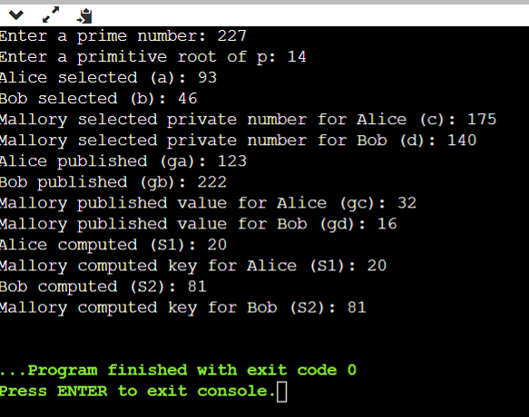

The use of a fixed generator g could potentially lead to a small subgroup attack if the attacker can choose the generator. Additionally, the code does not perform any authentication, which means that a man-in-the-middle (MITM) attack is possible, where Mallory intercepts the public keys and forwards them to Alice and Bob while impersonating each other, allowing Mallory to eavesdrop on their communication.

To fix these issues, the implementation should use a secure random generator for g, and perform authentication to prevent MITM attacks.

**Conclusion**: We successfully implemented Diffie Hellman Key exchange protocol. Demonstrate man in middle attack.